Triple Exponential Smoothing Forecasting Method Application Report & User Manual

Dated: May 9, 2024

**EXPONENTIAL SMOOTHING**

Exponential smoothing is the most widely used class of procedures for smoothing discrete time series in order to forecast the immediate future. The idea of exponential smoothing is to smooth the original series the way the moving average does and to use the smoothed series in forecasting future values of the variable of interest. In exponential smoothing, however, we want to allow the more recent values of the series to have greater influence on the forecast of future values than the more distant observations.

Exponential smoothing is a simple and pragmatic approach to forecasting, whereby the forecast is constructed from an **exponentially weighted average** of past observations. The largest weight is given to the present observation, less weight to the immediately preceding observation, even less weight to the observation before that, and so on (exponential decay of influence of past data)

Advantages

* Simple to operate
* Forecaster's knowledge or intuition can be used in forecasting.
* Useful method when sales data have a trend or seasonal pattern.
* Immediate response to a upturn or downturn in sales and used by many firms.

Disadvantages

* Smoothing constant is somewhat arbitrary
* Long term and new product forecasting are not possible.

**TIME SERIES**

A time series consists of data which are arranged chronologically. It establishes a relationship between two variables in which one of the variable is independent variable i.e. the time and other variable y is the dependent variable whose value changes with regard to time variable e.g. total agricultural production in different years.

A time series consists of the following four components:

* **Trend** - Trend refers to long term movement in the time series, i.e. Trend refers to the ability of the time series to increase or to decrease or to remain constant over a long period of time. If the values of the variable are scattered around a straight line, then we have a linear trend. Otherwise, the trend is non-linear e.g. long- term changes in productivity.
* **Seasonal variations** - Seasonal variations involve patterns of change within a year that tend to be repeated from year to year. They are short- term periodic movements. The time interval of occurrence of seasonal variations may vary from a few hours to a few weeks or a few months. To note the seasonal variations, the data must be recorded at least quarterly, monthly, weekly, or daily depending on the nature of the variable under consideration.
* **Cyclical variations** - Cyclical variations are oscillatory variations in the time series that oscillate around the trend line with period of oscillation as more than one year. These variations do not follow any regular pattern and move in somewhat unpredictable manner. These are upswings and downswings in the time series that are observable over extended periods of time.
* **Irregular variations** - The irregular component of the time series is the residual factor that accounts for the deviations of the actual time series values from what we would expect from the trend, seasonal, and cyclical components. It accounts for the random availability in the time series. The irregular component is caused by the short-term, unanticipated, and non-recurring factors that affect the time series, viz. earthquakes, floods etc.

**Measures**

|  |  |  |  |
| --- | --- | --- | --- |
| Forecast Accuracy Measure | | Formula | Description |
| Level Parameter | LS |  | The level component represents the baseline value of the time series. It's updated using a combination of the observed value, the trend component, and the seasonality component. |
| Trend Parameter | TS |  | The seasonal component represents the repeating pattern or seasonality in the time series. It's updated using a combination of the observed value, the level component, and the previous seasonal component. |
| Seasonality  Parameter | SS |  | The overall forecast is calculated by combining the level, trend, and seasonal components. |
| Root Mean Squared Error | RMSE |  | RMSE is the square root of the average of the squares of the differences between predicted and observed values. |
| Bias | Bias |  | Bias represents the difference between the average of predicted values and the average of observed values. |
| Mean Square Error | MSE |  | MSE is the average of the squares of the differences between predicted and observed values. |
| Mean Absolute Deviation | MAD |  | MAD measures the average absolute difference between predicted and observed values. |
| Mean Absolute Percentage Error | MAPE |  | MAPE measures the average percentage difference between predicted and observed values. |
| Max Abs. Error | MaxAbs.Error |  | Max Absolute Error represents the maximum absolute difference between predicted and observed values. |

**RUNNING THE APPLICATION**

Triple Exponential Smoothing (“TES”) is a method which uses three parameters of level (LS), trend (TS) and seasonality (SS) to generate forecasting. This application uses the inputted training data and finds the above-mentioned parameters by minimizing the RMSE and any other performance measures, if selected. The application also allows you to decide on the parameters values as well as visualize the results of the forecast with a graph.

This application uses the inputted training data and finds the above-mentioned parameters by minimizing the RMSE and any other performance measures, if selected. The application also allows you to decide on the parameters values as well as visualize the results of the forecast with a graph.

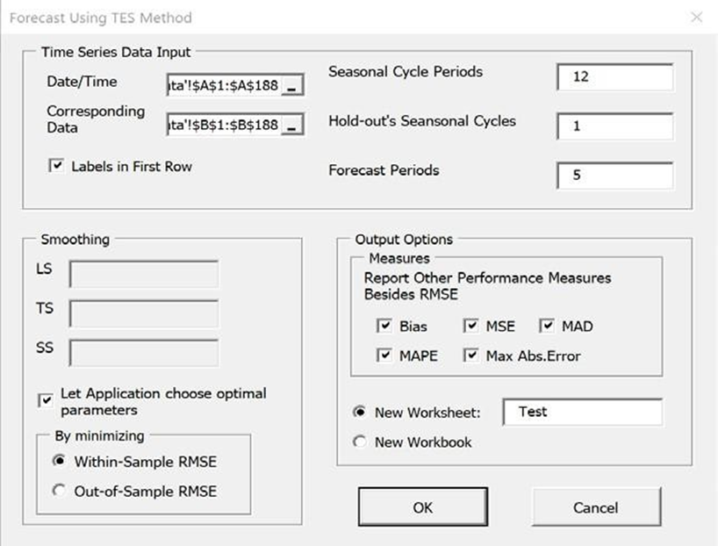

By clicking on the button “Run Application” in the dashboard, you will see a form called “Forecast Using TES Method” asking for the necessary data among the provided options. For users with excel version earlier than 2016, the application will ask to select the worksheet where data is located (See appendix 1.1). In either case, make sure the workbook which contains data set is open before you run the application.

The form begins by asking you:

Time series data input:

* Select the Date/ time inputs from your data workbook;
* Select the corresponding time series data to be used in forecasting;
* Number of periods in each seasonal cycle, p: The period of seasonality, e.g., data has a tendency to exhibit behavior that repeats itself every p periods;
* If the user entered 0 for the hold out cycles, out of sample measures will be excluded from the calculations. As a result, you will only see the within-sample values of performance measures.
* The part of the data that will be used as the “holdout” data, a.k.a. “out-of-sample” data. The rest of the data will be the “training” data, a.k.a. “in-sample” data. Enter zero if you do not want a hold-out analysis;
* Number of forecasts into the future. Enter zero if you do not want the application to do any forecast into future.

Output options:

* Which of the following performance measures (besides RMSE) should the application report, if any: mean squared error (MSE), bias (BIAS), mean absolute deviation (MAD), and mean absolute percent error (MAPE), and maximum absolute error (Max Abs.Error);
* Should the outputs be displayed in a new worksheet, then enter a name for the worksheet, or in a new workbook.

Smoothing:

* Whether the user wants to provide values for level, trend, and seasonality smoothing constants (LS, TS, and SS, respectively), or whether the application decides on the optimal values;
* And lastly, if the smoothing values should be calculated by minimizing within sample or out of Sample RMSE.

After entering the necessary data, you may click the forecast button. The application will check the following before running presenting a report:

* Range of selected dates and its corresponding data should be the same. Ensure you select a valid range for this section as VBA will perform an error check. If titles of these columns are selected too, make sure “Labels in fist row” is selected;
* Number of periods in seasonal cycle and Number of cycles for hold-out analysis should be entered as an integer bigger than zero. If hold out value is equal to zero, the whole selected data set will be used for forecasting;
* The “number of forecast periods” textbox is the number of periods you would like to forecast past the last data point entered. Ensure you enter a positive integer as VBA will not advance past this form otherwise;
* By default, “Let the application choose optimal parameters” is selected which means that Smoothing parameters can be found by the application. You also have the option to select either “Within-sample” or “Out-of-Sample” data for this calculation;
* Should you decide on using your own values, ensure the above- mentioned check box is not selected first. Enter a number between 0 and 1 exclusively. By selecting a value closer to 1, more weight is given to more recent data;
* By selecting “New Worksheet” in the output options section, the application will show the results in a new worksheet. The name of this worksheet shouldn’t be a copy of other sheets in this workbook.

After completing the Input Data form, you may select OK to complete the forecast.

Remember that this application may take a couple minutes to fully present the report. From that point, a new worksheet/workbook will be created. It will contain all results of the TES forecast. The results of this sheet are dependent upon the inputs of the input data form.

Refer to the following image for a completed report sample.

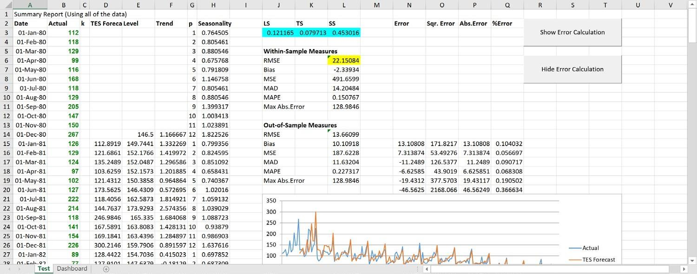

Cells in blue are changing variables (independent variables), meaning you may change the values in those cells if you want to. Current values are the value you gave initially, or the optimal values chosen by application. Cell in yellow is the objective variable (dependent variable). If you let the application decide the optimal values for smoothing, this value in yellow cell would be minimized. If you want to check detailed calculation on error, absolute error etc. You may click button “Show Error Calculation” on the report page.

Note that that sample report contains hold-out analysis and forecast into future. For reports without hold-out analysis, there will be no “Out-of-Sample Measures”.

**Structure of the Application Code**

The sub that generates the forecast result calls the following major subs from the main sub in the following order: InputFormula, ErrorCalculation, Measures, RunSolver, IntoFuture, and BuildChart. There are also four other subs which do not functionally matter to this application.

**InputFormula**

This sub includes all the formulas used in the final report page. It starts with calculating level, trend and seasonality initialization by using LS, TS and SS values and continues to training and hold out data. If the holdout cycle was entered as zero, this sub will use the whole data set for forecasting. If in the user form, you have entered these values manually, the formulas will incorporate them into the formulas.

**ErrorCalculation**

By starting to generate titles for each performance measure, the sub continues to calculate and show error, Sqr. Error, Abs.Error and %Error corresponding to its data point. Whether you want to see the calculations or not are optional and can be decided by clicking on either of the following buttons found on the right side of the forecasting result page. These button will be created by two separate subs at the end.

“Show Error Calculation” and “Hide Error Calculation”.

**IntoFuture**

Depending on whether the user enters any integers other than zero in the number of forecasting cycles text box in the form, the application will start running the future forecasting. For this sub,

an if statement checks the number of holdout cycles and if it’s not equal to zero, autofill the forecast range with previous cycle formulas. However, if the holdout cycle is zero, the sub writes the formulas such as VLookup to create the forecast value.

**RunSolver**

By minimizing RMSE value for either Within-Sample or Out-of-sample data, the values of smoothing parameters are found by solver. The constraints are forcing the smoothing values to be between 0 and 1 exclusively. Multi-start function enables solver to find the global minimum value of RMSE.

**BuildChart**

After running through the above subs, the next sub that will be called is the BuildChart. This sub will select the data found within the output worksheet named by you in order to create a chart.

The chart will graph the user inputted data, along with the TES results from the forecast. It is especially useful in visualizing any found parameters found in the data.

**Others**

The following subs give user options to hide or show error calculation: CreateButton1; CreateButton2; ShowCalculation; Hide Calculation.

There is another sub DeleteWS assigned to button “Delete All Report” allows user to delete all worksheets except for dashboard.

**APPENDIX**

Appendix 1.1

